BROOMFIELD FC
FUNDRAISING CLUB SHOP
NEW FOR 2018/19
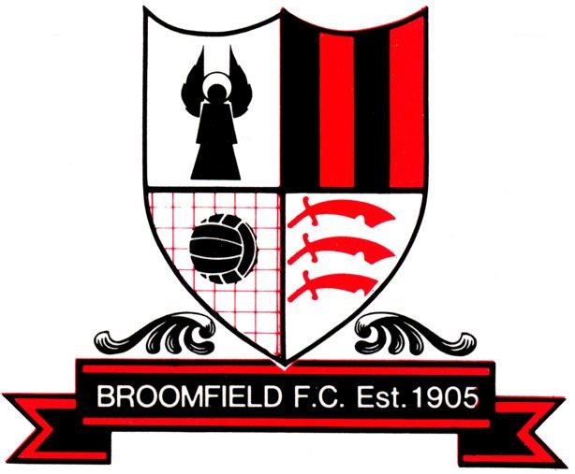
- BFC 2 sided Scarf £10.00

- BFC THERMO CUP* £10.00 *INCLUDES 50% OFF TEA & COFFEE REFILLS FOR 2018/19 SEASON!
Reduced to Clear
- BFC DRAWSTRING BAGS – £5
- BFC BLACK BEANIE HAT - £8

